SCHOOL OF COMPUTER SCIENCE AND ARTIFICIAL INTELLIGENCE |  |  |  |  | DEPARTMENT OF COMPUTER SCIENCE ENGINEERING
Program Name: B. Tech |  |  |  | Assignment Type: Lab |  |  | Academic Year:2025-2026
Course Coordinator Name |  |  |  | Venkataramana Veeramsetty
Instructor(s) Name |  |  |  | Dr. V. Venkataramana (Co-ordinator)  Dr. T. Sampath Kumar  Dr. Pramoda Patro  Dr. Brij Kishor Tiwari  Dr.J.Ravichander  Dr. Mohammand Ali Shaik  Dr. Anirodh Kumar  Mr. S.Naresh Kumar  Dr. RAJESH VELPULA  Mr. Kundhan Kumar  Ms. Ch.Rajitha  Mr. M Prakash  Mr. B.Raju  Intern 1 (Dharma teja)  Intern 2 (Sai Prasad)  Intern 3 (Sowmya)  NS_2 ( Mounika)
Course Code |  |  | 24CS002PC215 | Course Title |  | AI Assisted Coding
Year/Sem |  |  | II/I | Regulation |  | R24
Date and Day  of Assignment |  |  | Week6 - Monday | Time(s)
Duration |  |  | 2 Hours | Applicable to  Batches
AssignmentNumber:12.5(Present assignment number)/24(Total number of assignments)
 | Q.No. | Question |  |  |  |  |  | Expected Time  to complete
 | 1 | Lab 12: Algorithms with AI Assistance – Sorting, Searching, and Optimizing Algorithms  Lab Objectives:  - Apply AI-assisted programming to implement and optimize sorting and searching algorithms.  - Compare different algorithms in terms of efficiency and use cases.  - Understand how AI tools can suggest optimized code and complexity improvements.  Task 1: Sorting Student Records for Placement Drive  Scenario:  SR University is preparing for a campus placement drive. The Training and Placement Cell needs student records sorted by CGPA in descending order to easily shortlist candidates.  - Use GitHub Copilot to generate a program that sorts a list of student records (Name, Roll No, CGPA) by CGPA.  - Implement both Quick Sort and Merge Sort using AI assistance.  - Compare the runtime performance of both algorithms on large datasets.  - Write a function that outputs the top 10 students with the highest CGPA.  Task 2: Optimized Search in Online Library System  Scenario:  SR University’s digital library has thousands of research papers. Students frequently search for a paper by title or author name. The current linear search is too slow.  - Use GitHub Copilot to implement Binary Search and Hash-based Search for faster lookups.  - Load a dataset of book titles and authors (CSV or JSON file).  - Allow the user to input a keyword and return all matching entries.  - Compare the efficiency of linear search vs binary search vs hashing using test cases.  Task 3: Route Optimization for AUV Swarm  Scenario:  A research team at SR University is simulating Autonomous Underwater Vehicle (AUV) swarms. Each AUV must visit multiple underwater sensors, and the goal is to minimize travel distance (like the Traveling Salesman Problem).  - With GitHub Copilot, implement an algorithm to optimize the route:  - Start with a Greedy approach.  - Improve with Genetic Algorithm (GA) or Simulated Annealing (SA).  - Use a dataset of sensor coordinates (x, y).  - Visualize the optimized route using a plotting library (e.g., Matplotlib).  - Compare the optimized solution with a random path in terms of distance travel.  Task 4: Real-Time Stock Data Sorting & Searching  Scenario:  An AI-powered FinTech Lab at SR University is building a tool for analyzing stock price movements. The requirement is to quickly sort stocks by daily gain/loss and search for specific stock symbols efficiently.  - Use GitHub Copilot to fetch or simulate stock price data (Stock Symbol, Opening Price, Closing Price).  - Implement sorting algorithms to rank stocks by percentage change.  - Implement a search function that retrieves stock data instantly when a stock symbol is entered.  - Optimize sorting with Heap Sort and searching with Hash Maps.  - Compare performance with standard library functions (sorted(), dict lookups) and analyze trade-offs. |  |  |  |  |  | Week6 - Friday

Task 1: Sorting Student Records for Placement Drive
Scenario:
SR University is preparing for a campus placement drive. The Training and Placement Cell needs student records sorted by CGPA in descending order to easily shortlist candidates.

- Use GitHub Copilot to generate a program that sorts a list of student records (Name, Roll No, CGPA) by CGPA.
- Implement both Quick Sort and Merge Sort using AI assistance.
- Compare the runtime performance of both algorithms on large datasets.
- Write a function that outputs the top 10 students with the highest CGPA.

Prompt : generate a program that sorts a list of student records (Name, Roll No, CGPA) by CGPA and Implement both Quick Sort and Merge Sort using AI assistance by Comparing the runtime performance of both algorithms on large datasets and a function that outputs the top 10 students with the highest CGPA

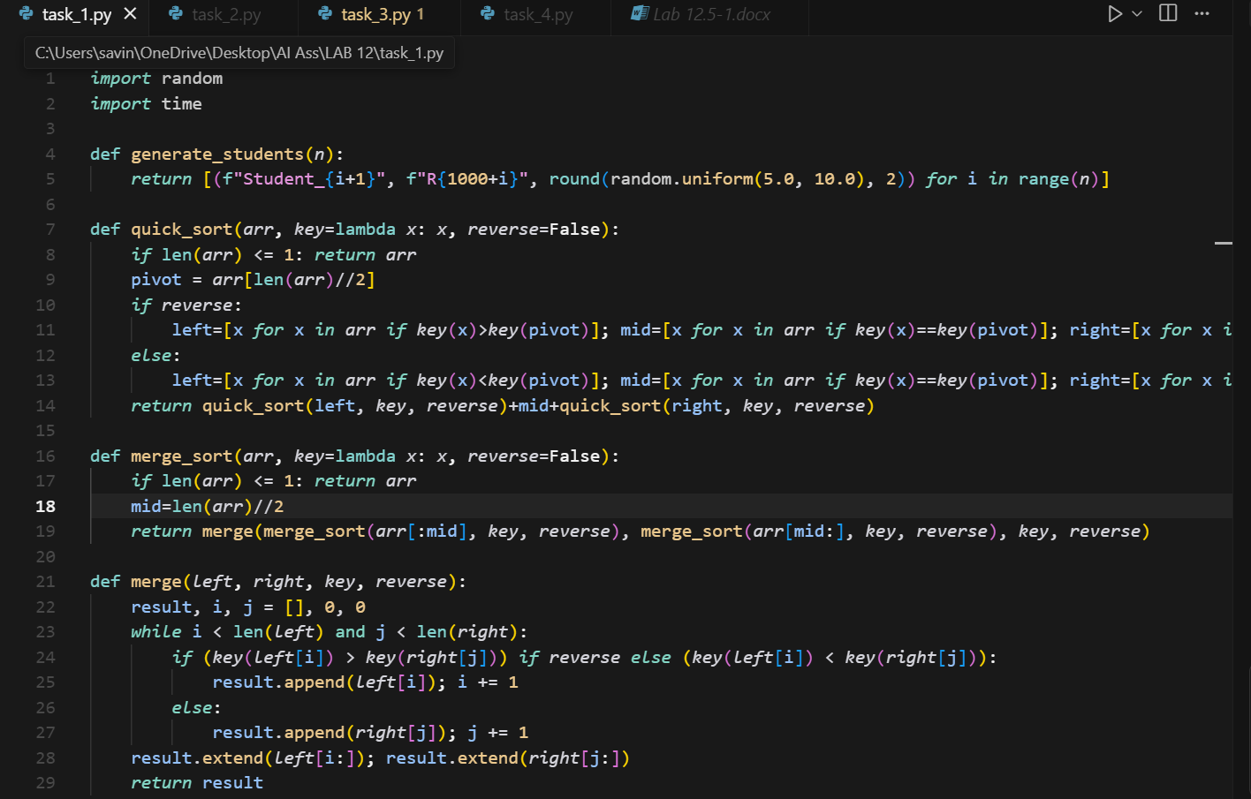

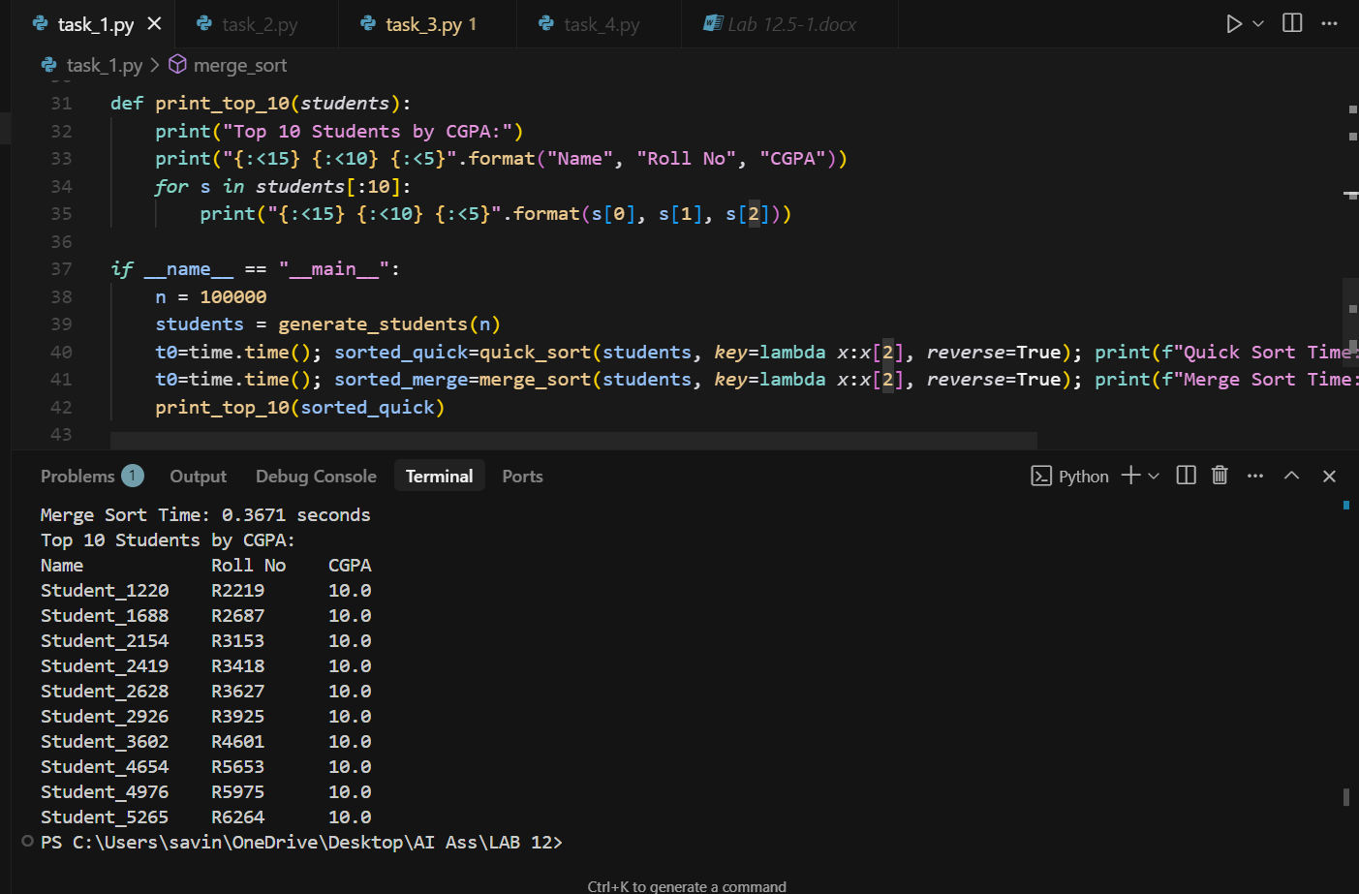

Task 2: Optimized Search in Online Library System
Scenario:
SR University’s digital library has thousands of research papers. Students frequently search for a paper by title or author name. The current linear search is too slow.

- Use GitHub Copilot to implement Binary Search and Hash-based Search for faster lookups.
- Load a dataset of book titles and authors (CSV or JSON file).
- Allow the user to input a keyword and return all matching entries.
- Compare the efficiency of linear search vs binary search vs hashing using test cases.

PROMPT :

Implement Binary Search and Hash-based Search for faster lookups and Load a dataset of book titles and authors (CSV or JSON file).
Allow the user to input a keyword and return all matching entries. Compare the efficiency of linear search vs binary search vs hashing using test cases.

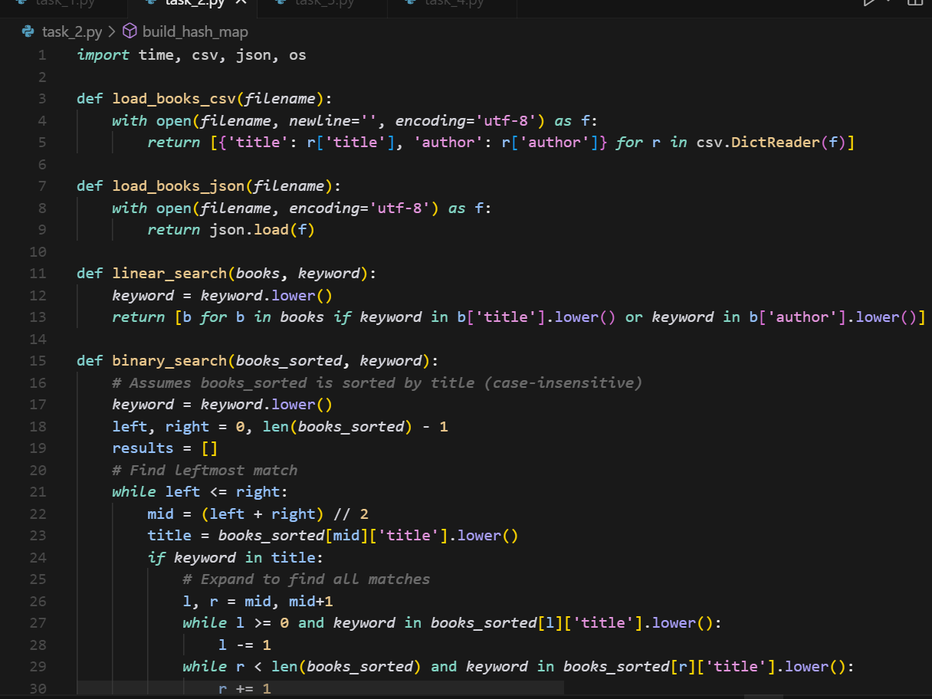

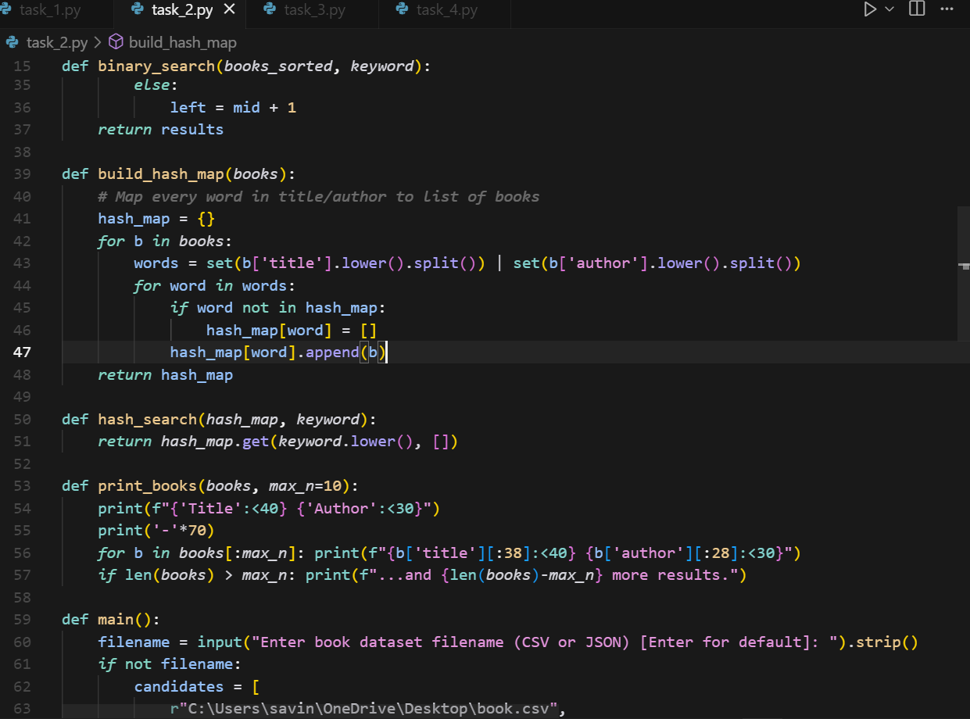

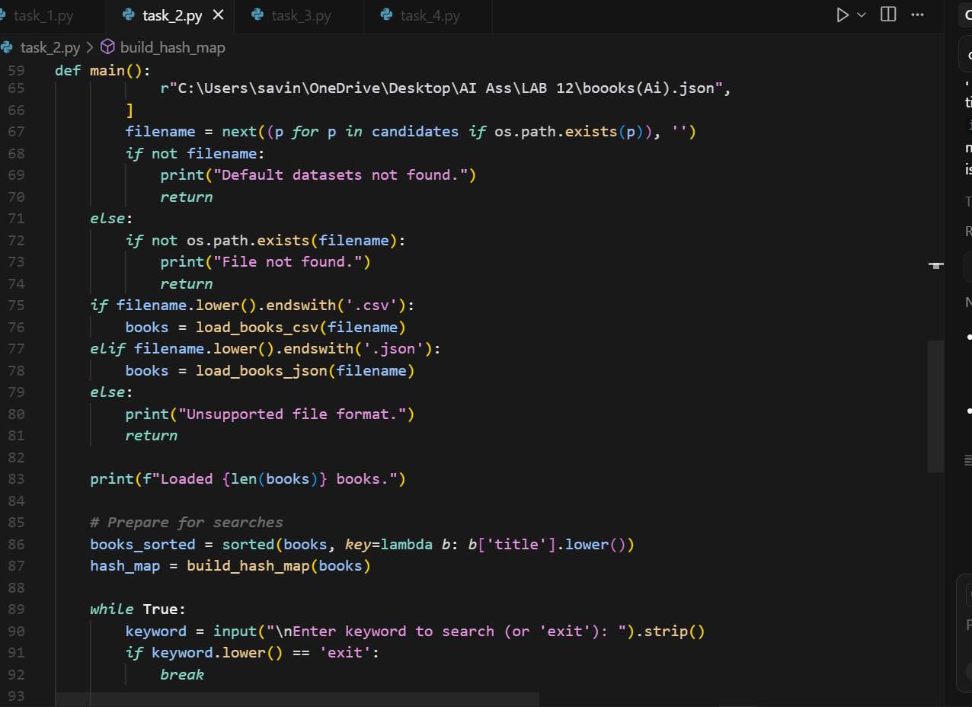

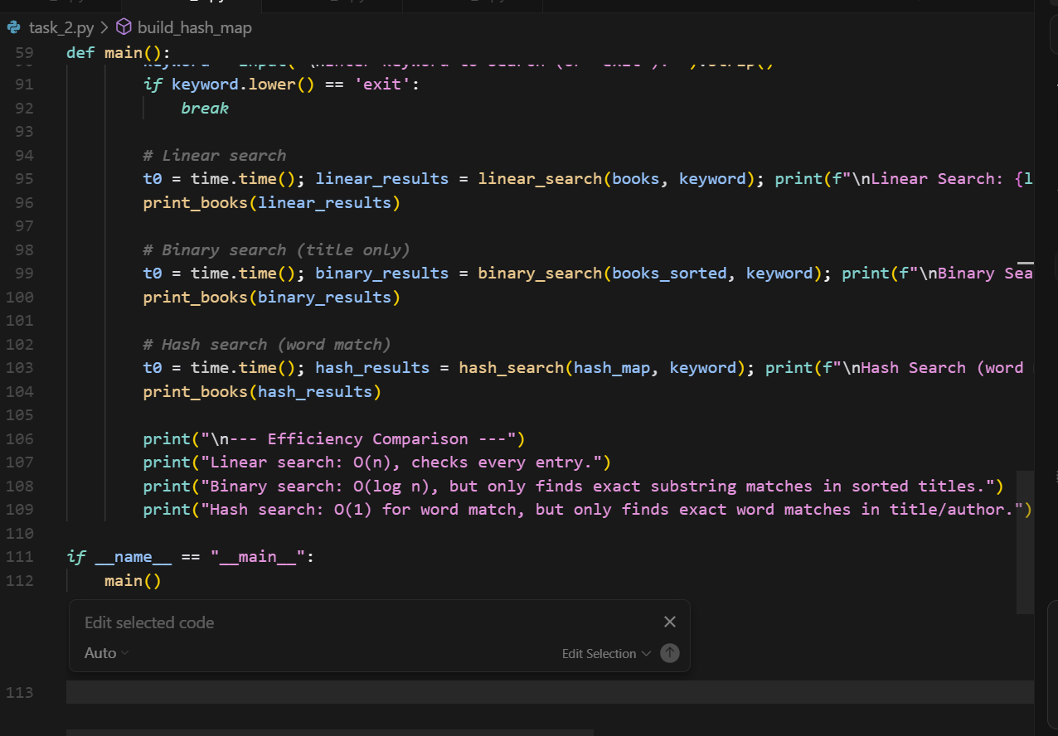

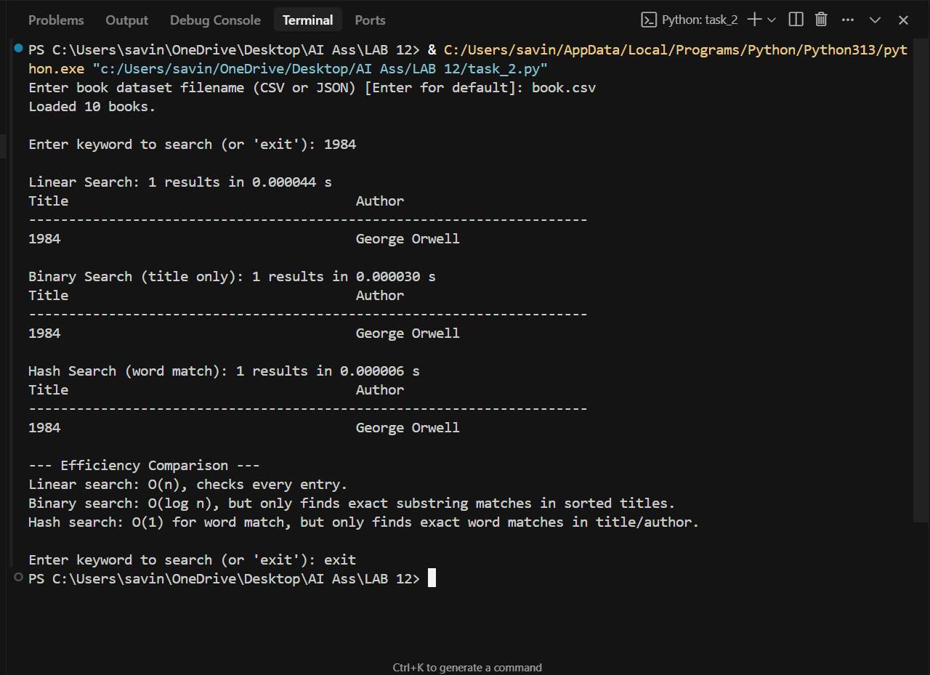

Task 3: Route Optimization for AUV Swarm

Scenario:
A research team at SR University is simulating Autonomous Underwater Vehicle (AUV) swarms. Each AUV must visit multiple underwater sensors, and the goal is to minimize travel distance (like the Traveling Salesman Problem).

- With GitHub Copilot, implement an algorithm to optimize the route:
  - Start with a Greedy approach.
  - Improve with Genetic Algorithm (GA) or Simulated Annealing (SA).
- Use a dataset of sensor coordinates (x, y).
- Visualize the optimized route using a plotting library (e.g., Matplotlib).
- Compare the optimized solution with a random path in terms of distance travel.

PROMPT :
Implement an algorithm to optimize the route. Start with a Greedy approach. Improve with Genetic Algorithm (GA) or Simulated Annealing (SA).Use a dataset of sensor coordinates (x, y) and Visualize the optimized route using a plotting library (e.g.,Matplotlib) and also Compare the optimized solution with a random path in terms of distance travel.

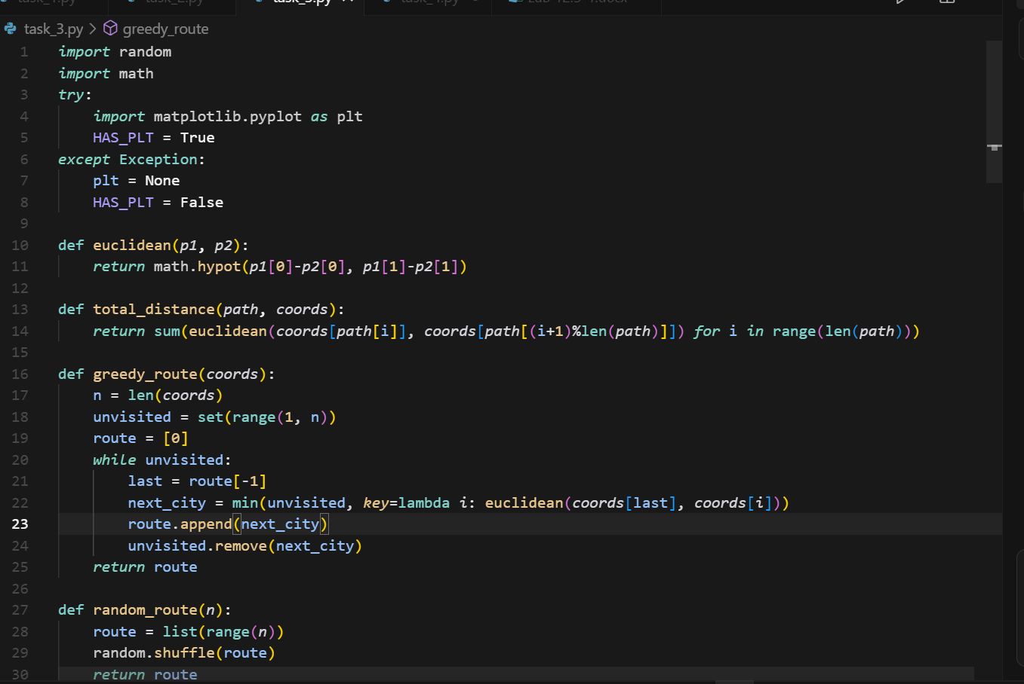

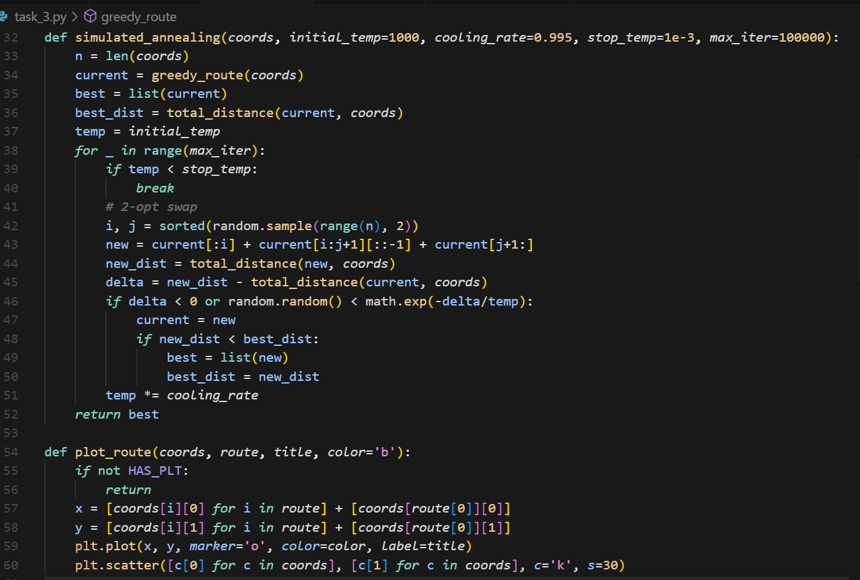

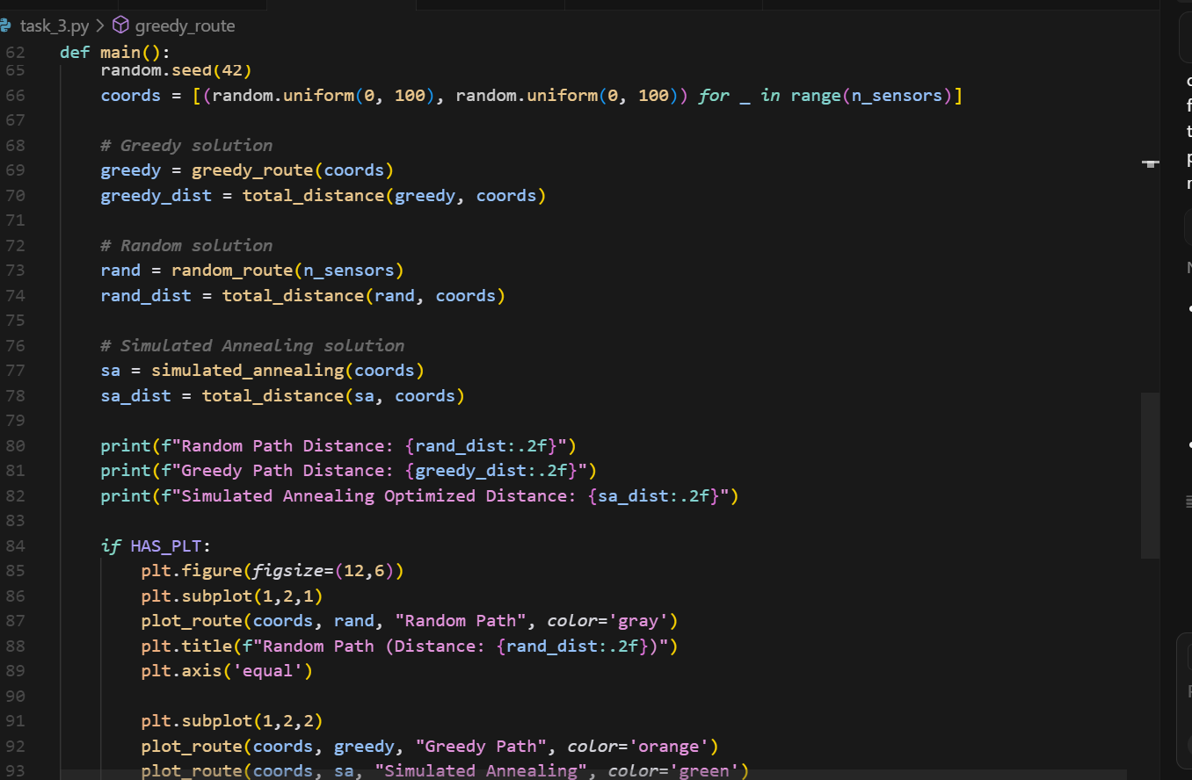

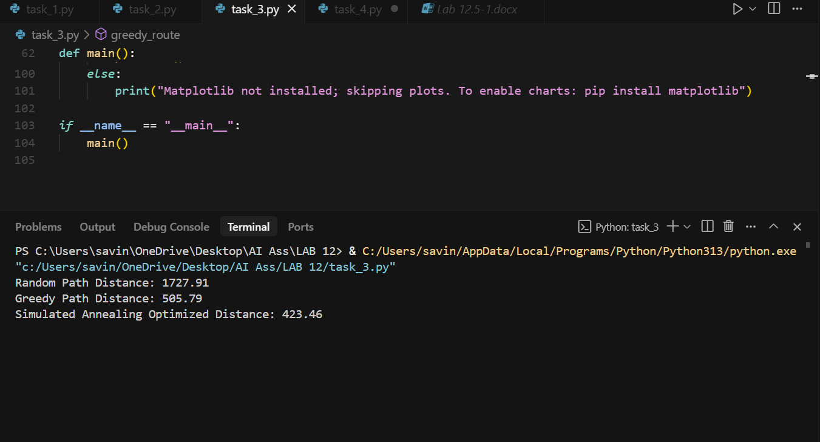

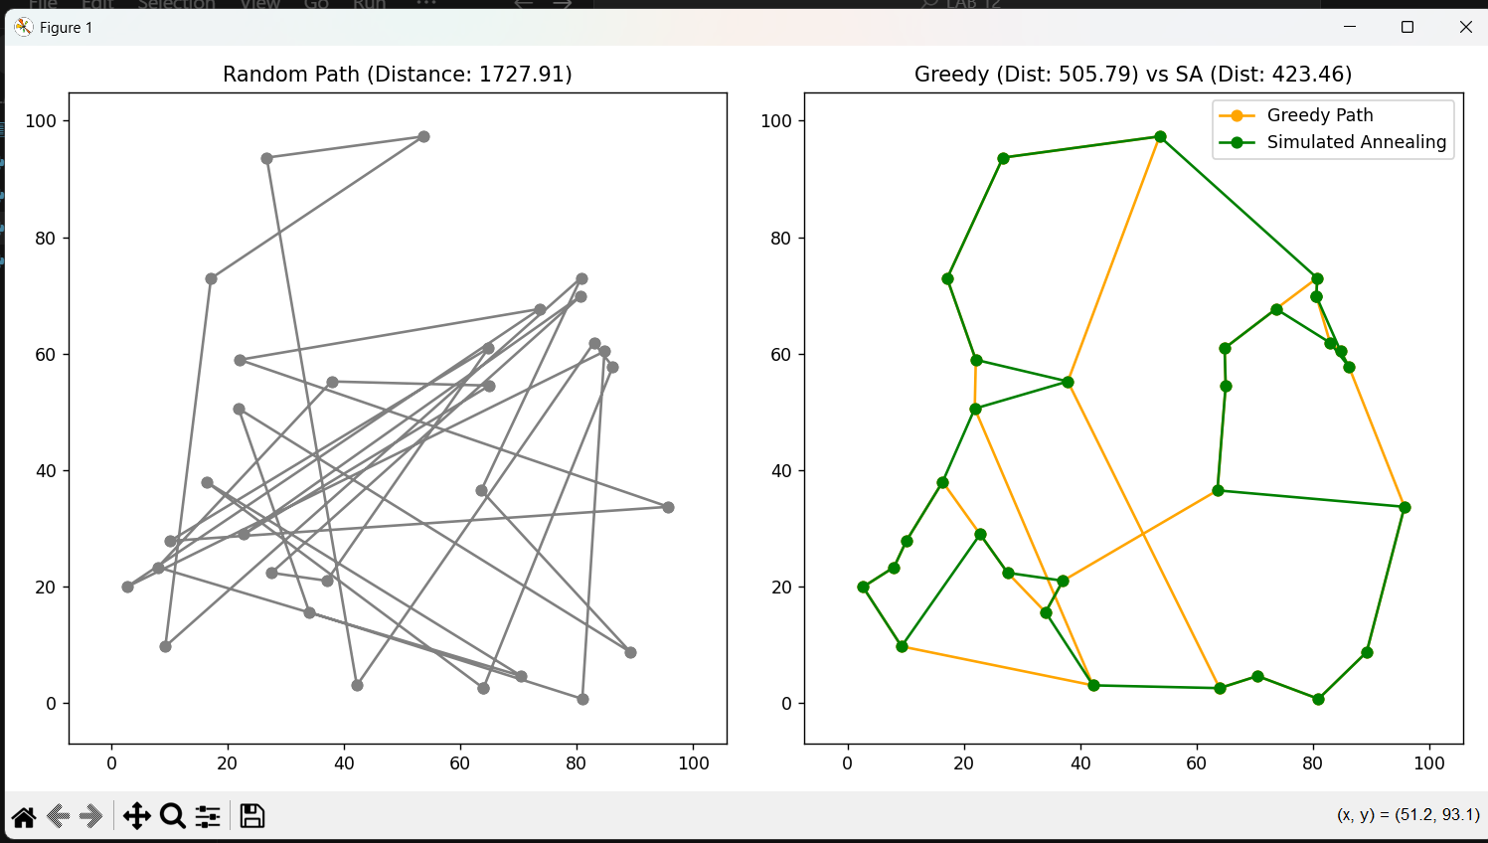

Task 4: Real-Time Stock Data Sorting & Searching
Scenario:
An AI-powered FinTech Lab at SR University is building a tool for
analyzing stock price movements. The requirement is to quickly sort
stocks by daily gain/loss and search for specific stock symbols
efficiently.
• Use GitHub Copilot to fetch or simulate stock price data (Stock
Symbol, Opening Price, Closing Price).
• Implement sorting algorithms to rank stocks by percentage
change.
• Implement a search function that retrieves stock data instantly
when a stock symbol is entered.
• Optimize sorting with Heap Sort and searching with Hash
Maps.
• Compare performance with standard library functions (sorted(),dict lookups) and analyze trade-offs

PROMPT :
Fetch or simulate stock price data (Stock Symbol, Opening Price, Closing Price and Implement sorting algorithms to rank stocks by percentage change. Then Implement a search function that retrieves stock data instantly when a stock symbol is entered And also Optimize sorting with Heap Sort and searching with Hash Maps .Compare performance with standard library functions (sorted(), dict lookups) and analyze trade-offs.

